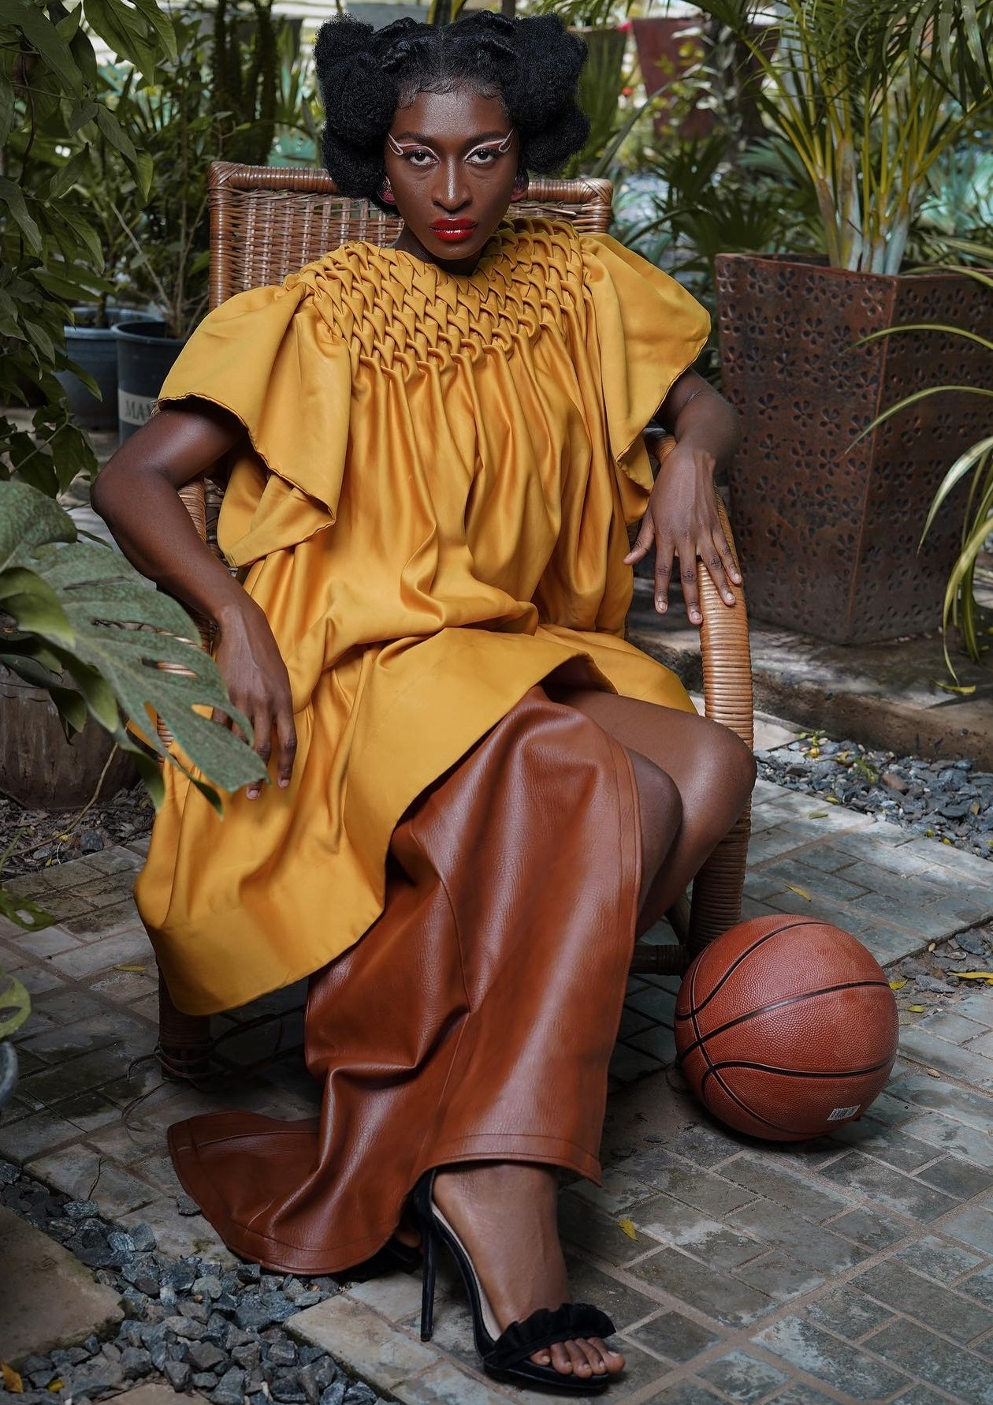

**EUNOIA**

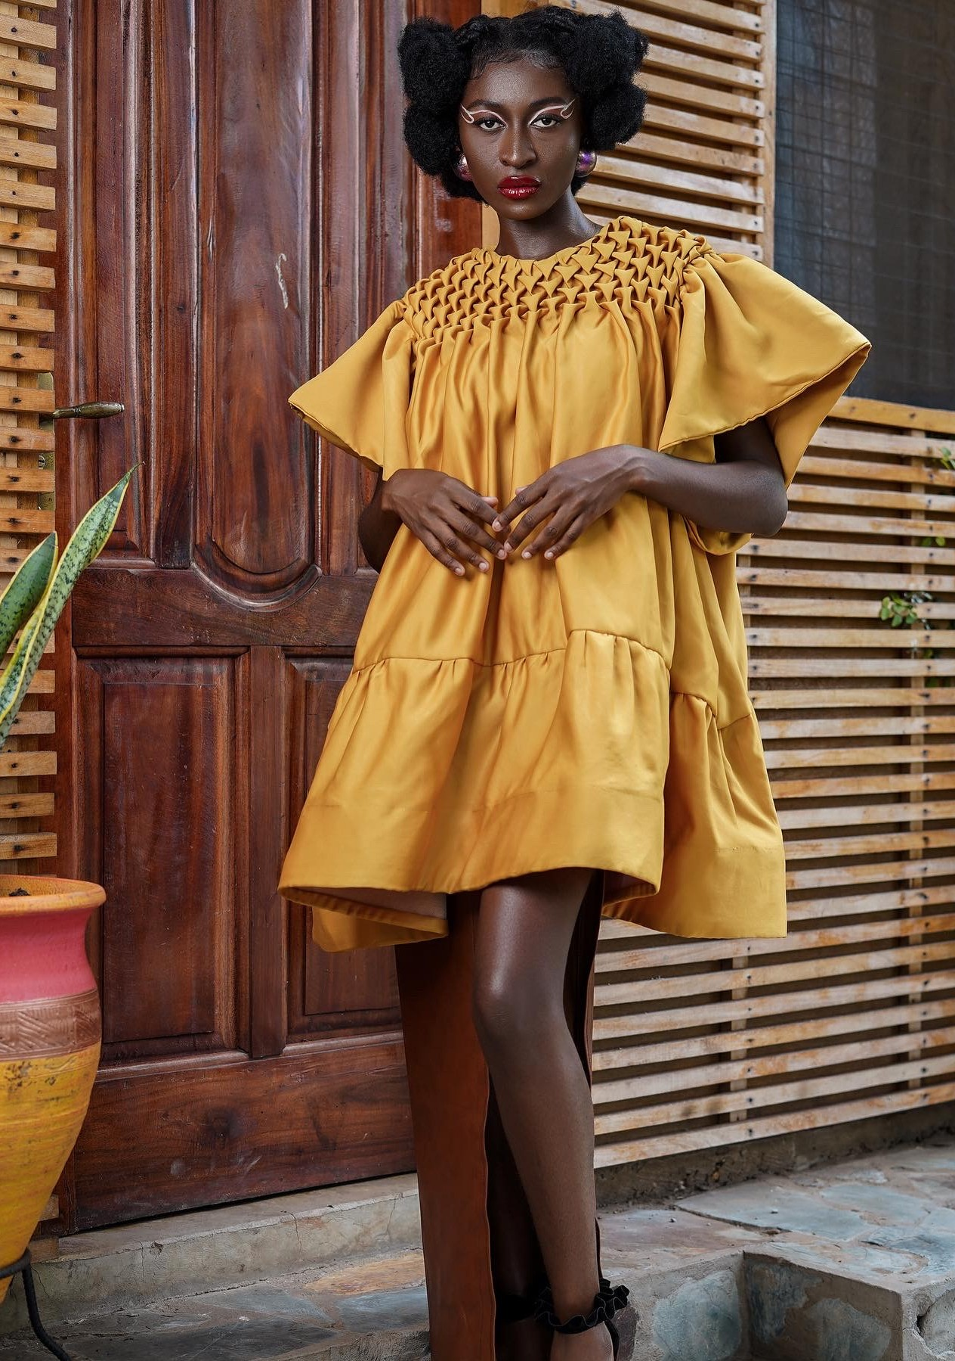

# CREATIVES

Models - @iam_beetha

@heisdele Juilet

Photographer- @elroysalam Videographer- @kraze_kreativez Make-up artist - @paintedbylinus_

Creative direction - @c.a.l.l.m.e.j.f.a.m.e Designer - @metakay

Accessories - @adjeleygh Garment production - @tads_edu

@qwabina agyei @ kobby @addymichael

# EUNOIA

Somewhere in the mid 90’s, a beautiful woman was betrothed to a man, who was born into a family so passionate about agriculture and inherited a number of farms from his dad.

Through agriculture he was able to cater for us through school and provided us with our basic needs.

Being an African with Ghanaian roots, where agriculture is mostly practiced in the rural areas, I want to showcase a collection inspired by agriculture and my parents passion for it.

Their toughness on the outside and sweetness on the inside just like the pineapple translated into the care they bestowed upon us and their farms, thus, making them think beautifully and teaching us to do same. This being the theme of our collection “EUNOIA” which is a Greek word meaning BEAUTIFUL THINKING. I expressed my EUNOIA in the fabric manipulation method known as “Arrow smocking” which was also inspired by the pineapple scales.

The collection seeks to empower the youth and women not to give up but focus on their goals irrespective of how painful or long it might be or take. This empowerment is shown forth through the fabric manipulation method use as it takes quite sometime to do but results in a beautiful piece.

The collection embodies the freedom of the mind, body and soul.

